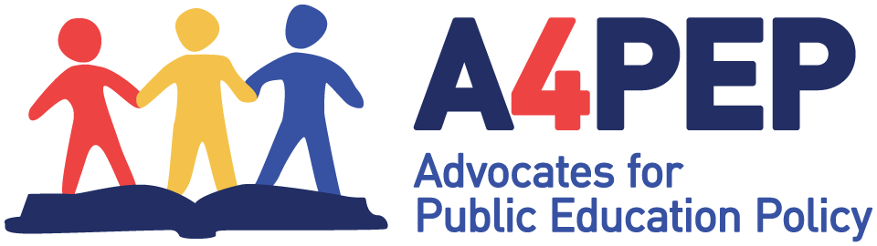

January 20, 2022

Dear members of the Colorado State Board of Education:

Advocates for Public Education Policy would like to provide you with our perspective regarding Central Elementary of Adams 14 and efforts to improve their turnaround accountability status. We think the best option would be to use the Community School Model.

Adopting this model would be best in our opinion because of the following facts about Central Elementary students:
- 89% are economically disadvantaged
- 90% are minority (80% Hispanic, high ELL)
- 16% scored at or above proficiency level in Math
- 19% scored at or above proficiency level in Reading
Research shows that schools with high-poverty student populations and large numbers of ELL students require an approach which spans beyond the classroom. Families who struggle with housing and food insecurity, language barriers, and access to adequate healthcare and mental health services have children who are less likely to do well in school.

Research also reveals that family income highly correlates with how well students perform on statewide standardized tests. The higher the family income, the higher the scores, and the lower the income, the lower the scores. This is not an opinion; it is backed by years of evidence.

If children are to succeed in school, the most effective, research-based approach is to address the "out-of-school" factors which affect learning and academic progress. If students have stable housing, adequate food and clothing, access to a doctor and dentist, enrichment opportunities, and parental and community support, their chances of academic success greatly improve.

The Community School Model - which involves incorporating local, state, and federal wraparound services and programs into the school community as supports for students and families – would be beneficial in helping Central Elementary students improve academically.

State statute allows for this option and is defined in current law. Furthermore, there are strong frameworks and guidelines readily available to the district and school in which to develop this model. The links below offer some information and examples.

Respectfully submitted,
Judy Solano
Chair of Advocates for Public Education Policy

Comm Schools ToolKit-final digi-web-72617.pdf (nea.org)
The call for community schools | School of Education | University of Colorado Boulder

